**Children’s Book Council of Australia**

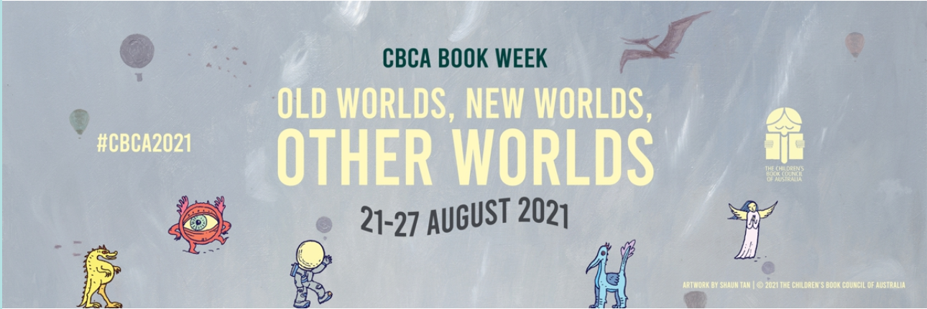**2021 Book Week at Birrong Girls High**

**ENTRY FORM – *Categories*:**

1. **Written Book Review** of less than 200 words on A4 paper.

2. **Original Fairy Tale** OR **Fantasy** of less than 200 words on A4 paper.

3. **Poster advertising a popular book or narrative** on A3 paper (supplied by the Teacher Librarian).

1. **Manga sequence** on A3 paper supplied by the Teacher Librarian
2. **Puppet** OR **Model** **of a favourite book character**.
3. **Recitation of a Poem** OR **Short Story** in less than 2 minutes held at lunchtime in the Library on Friday 27 August 2021. Props and costumes are permitted to enhance the performance.

***NB:*** **1 entry only per student in each category.**

***Prizes:*** Students will be able to select from a range of prizes to be presented on Friday, 27 August in the library - 3 prizes for each category.

***Further entry forms*** can be obtained from the Library.

***Closing date*** for all the above categories – Friday. 20 August, 2021.

- - - - - - - - - - - - - - - - - - - - - - - - - - - - - - - - - - - - - - - - - - - - - - - - - - - - - - - - - - - - - - -

*Please detach this section and return to the Library with your entry by Friday 20 August, 2021.*

(Make sure your entry is clearly marked with your name and class)

**Birrong Girls High School**

***ENTRY FORM - BOOK WEEK COMPETITION***

I wish to participate in the Book Week Competition in the following category:

**NB:** 1 entry only per student per category. (Please tick)

1/2. **Written Book Review** OR **original Fairy Tale or Fantasy**

of less than 200 words on A4 paper

3/4/5. **Poster** **advertising a popular book or narrative** on A3 paper

OR **short Manga sequence** OR **puppet** OR **model of a**

**favourite book character** (A3 paper supplied by the Teacher

Librarian).

6.  **Recitation of a poem** OR **short story** in less than 2 minutes

held at lunchtime in the Library on Friday 27 August 2021.

Props and costumes are permitted to enhance the performance.

**NAME:** ________________________________________ **ROLL CLASS: ____­­­_______**